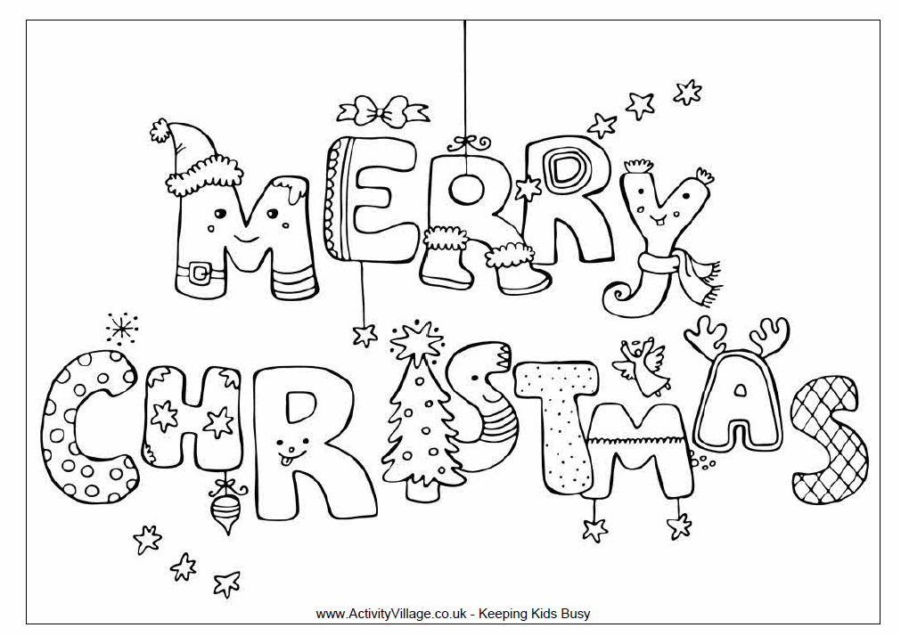
We wish you a Merry Christmas;
We wish you a Merry Christmas;
We wish you a Merry Christmas
and a Happy New Year.


